1. The main client for the site are any researchers and students.
2. At JSC Research, our main mission is to further human knowledge by providing simplistic research about technology. We do this by providing the reader with a simplistic version of complicated research papers. It happens too often that is research papers are very complicated to understand but JSC research is here to produce research that will be accessible to anyone and easy to understand for all target audiences.

JSC’s categories of research are all related to engineering and programming. On the engineering side, we have Biotechnology, Chemical Technology and Artificial intelligence. Our programming topics include software development and cyber security. Sometimes reading about research papers that contain information about engineering and programming are hard to understand, but with help from JSC research we will make research papers accessible and readable to everyone.

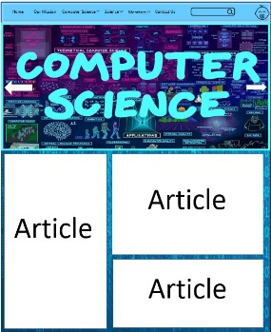

Index.html

Root Folder

Images

Content

DataBase’s

Mission%Statement.html

Intro%Statement.html

Users

Articles

The site structure was picked for accessibility and to make maintenance and updating/adding articles easier for the team. It benefits the user as well by having your basic pages available and having a database with articles makes it way easier for writers or people who want to upload an article.